Task 12. Simulate Gaming concepts using Pygame CO5-K5

Aim:
To Simulate Gaming concepts using Pygame

SnakeGame:

Problem 1.Write a python program to create a snakeGame using pygame package.

Conditions:
1.Set the window size
2.Create a snake
3.Make the snake to move in the directions when left,right,down and up key is pressed
4.When the snake hits the fruit.increase the score by 10
5.If the snake hits the window.Game over
Sample Output:

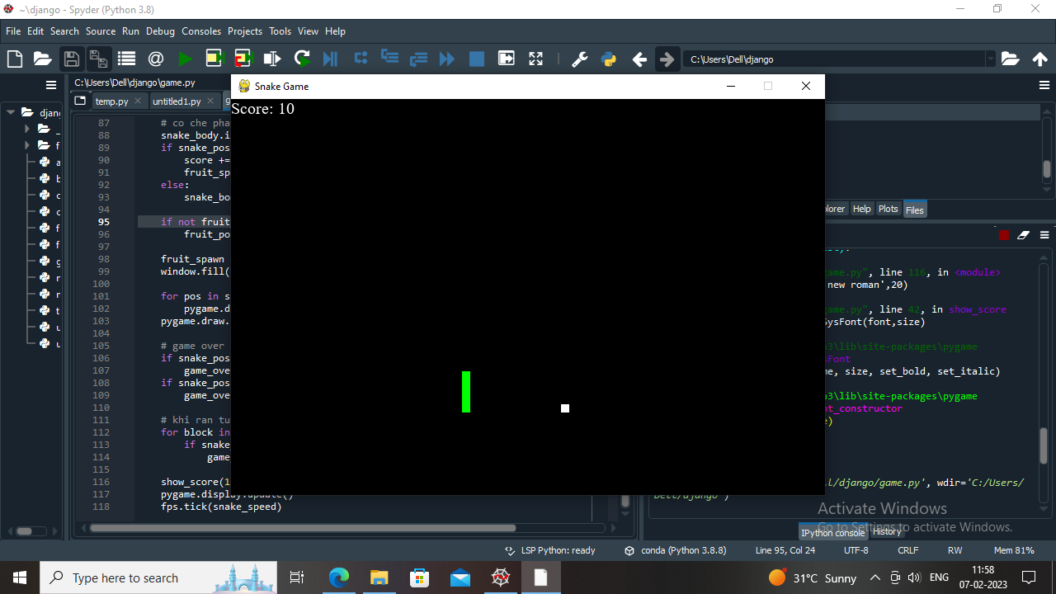

Algorithm:
- Import pygame package and initialize it
- Define the window size and title
- Create a Snake class which initializes the snake position, color, and movement
- Create a Fruit class which initializes the fruit position and color
- Create a function to check if the snake collides with the fruit and increase the score
- Create a function to check if the snake collides with the window and end the game
- Create a function to update the snake position based on the user input
- Create a function to update the game display and draw the snake and fruit
- Create a game loop to continuously update the game display, snake position, and check for collisions
- End the game if the user quits or the snake collides with the window
Program:
# importing libraries
import pygame
import time
import random

snake_speed = 15

# Window size
window_x = 720
window_y = 480

# defining colors
black = pygame.Color(0, 0, 0)
white = pygame.Color(255, 255, 255)
red = pygame.Color(255, 0, 0)
green = pygame.Color(0, 255, 0)
blue = pygame.Color(0, 0, 255)

# Initialising pygame
pygame.init()

# Initialise game window
pygame.display.set_caption('GeeksforGeeks Snakes')
game_window = pygame.display.set_mode((window_x, window_y))

# FPS (frames per second) controller
fps = pygame.time.Clock()

# defining snake default position
snake_position = [100, 50]

# defining first 4 blocks of snake body
snake_body = [[100, 50],
[90, 50],
[80, 50],
[70, 50]
]
# fruit position
fruit_position = [random.randrange(1, (window_x//10)) * 10,
random.randrange(1, (window_y//10)) * 10]

fruit_spawn = True

# setting default snake direction towards
# right
direction = 'RIGHT'
change_to = direction

# initial score
score = 0

# displaying Score function
def show_score(choice, color, font, size):

# creating font object score_font
score_font = pygame.font.SysFont(font, size)

# create the display surface object
# score_surface
score_surface = score_font.render('Score : ' + str(score), True, color)

# create a rectangular object for the text
# surface object
score_rect = score_surface.get_rect()

# displaying text
game_window.blit(score_surface, score_rect)

# game over function
def game_over():

# creating font object my_font
my_font = pygame.font.SysFont('times new roman', 50)

# creating a text surface on which text
# will be drawn
game_over_surface = my_font.render(
'Your Score is : ' + str(score), True, red)

# create a rectangular object for the text
# surface object
game_over_rect = game_over_surface.get_rect()

# setting position of the text
game_over_rect.midtop = (window_x/2, window_y/4)

# blit will draw the text on screen
game_window.blit(game_over_surface, game_over_rect)
pygame.display.flip()

# after 2 seconds we will quit the program
time.sleep(2)

# deactivating pygame library
pygame.quit()

# quit the program
quit()

# Main Function
while True:

# handling key events
for event in pygame.event.get():
if event.type == pygame.KEYDOWN:
if event.key == pygame.K_UP:
change_to = 'UP'
if event.key == pygame.K_DOWN:
change_to = 'DOWN'
if event.key == pygame.K_LEFT:
change_to = 'LEFT'
if event.key == pygame.K_RIGHT:
change_to = 'RIGHT'

# If two keys pressed simultaneously
# we don't want snake to move into two
# directions simultaneously
if change_to == 'UP' and direction != 'DOWN':
direction = 'UP'
if change_to == 'DOWN' and direction != 'UP':
direction = 'DOWN'
if change_to == 'LEFT' and direction != 'RIGHT':
direction = 'LEFT'
if change_to == 'RIGHT' and direction != 'LEFT':
direction = 'RIGHT'

# Moving the snake
if direction == 'UP':
snake_position[1] -= 10
if direction == 'DOWN':
snake_position[1] += 10
if direction == 'LEFT':
snake_position[0] -= 10
if direction == 'RIGHT':
snake_position[0] += 10

# Snake body growing mechanism
# if fruits and snakes collide then scores
# will be incremented by 10
snake_body.insert(0, list(snake_position))
if snake_position[0] == fruit_position[0] and snake_position[1] == fruit_position[1]:
score += 10
fruit_spawn = False
else:
snake_body.pop()

if not fruit_spawn:
fruit_position = [random.randrange(1, (window_x//10)) * 10,
random.randrange(1, (window_y//10)) * 10]

fruit_spawn = True
game_window.fill(black)

for pos in snake_body:
pygame.draw.rect(game_window, green,
pygame.Rect(pos[0], pos[1], 10, 10))
pygame.draw.rect(game_window, white, pygame.Rect(
fruit_position[0], fruit_position[1], 10, 10))
# Game Over conditions
if snake_position[0] < 0 or snake_position[0] > window_x-10:
game_over()
if snake_position[1] < 0 or snake_position[1] > window_y-10:
game_over()
# Touching the snake body
for block in snake_body[1:]:
if snake_position[0] == block[0] and snake_position[1] == block[1]:
game_over()
# displaying score continuously
show_score(1, white, 'times new roman', 20)

# Refresh game screen
pygame.display.update()

# Frame Per Second /Refresh Rate
fps.tick(snake_speed)

Output
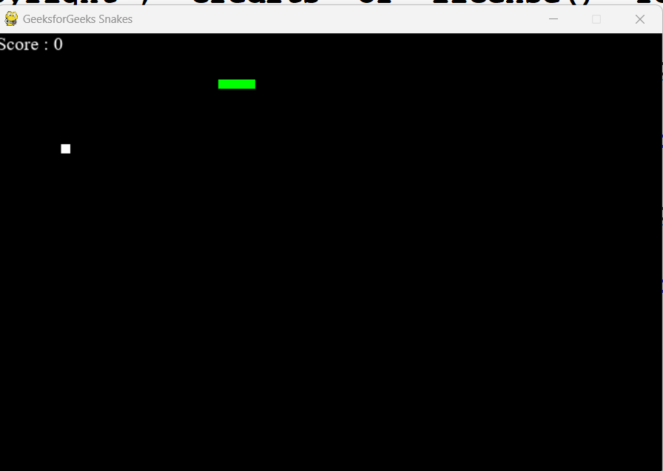

Problem 2.Write a python program to Develop a chess board using pygame.

Sample output:

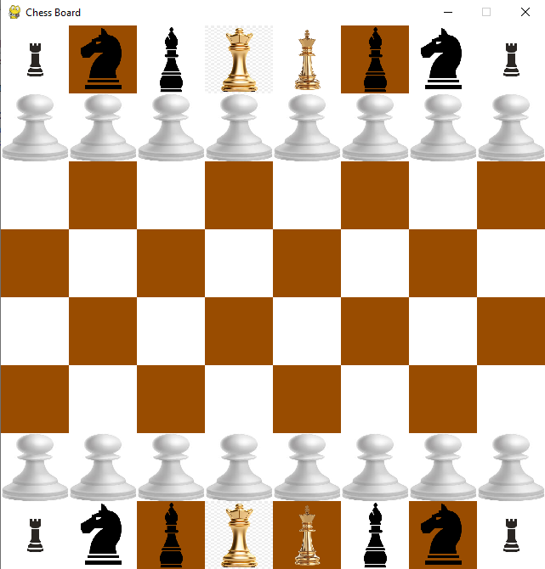

Algorithm:
- Import pygame and initialize it.
- Set screen size and title.
- Define colors for the board and pieces.

Define a function to draw the board by looping over rows and columns and drawing squares of different colors.
- Define a function to draw the pieces on the board by loading images for each piece and placing them on the corresponding square.
- Define the initial state of the board as a list of lists containing the pieces.
- Draw the board and pieces on the screen.
- Start the game loop.

Program:
import pygame

# Initialize pygame
pygame.init()

# Set screen size and title
screen_size = (640, 640)
screen = pygame.display.set_mode(screen_size)
pygame.display.set_caption('Chess Board')

# Define colors
black = (0, 0, 0)
white = (255, 255, 255)
brown = (153, 76, 0)

# Define function to draw the board
def draw_board():
for row in range(8):
for col in range(8):
square_color = white if (row + col) % 2 == 0 else brown
square_rect = pygame.Rect(col * 80, row * 80, 80, 80)
pygame.draw.rect(screen, square_color, square_rect)

# Define function to draw the pieces
def draw_pieces(board):
SQUARE_SIZE = 80 # or whatever your square size is

piece_images = {

'p': pygame.transform.scale(pygame.image.load('E:/SUMMER 25_26/PYTHON/lab/New folder/pawn.png'), (SQUARE_SIZE, SQUARE_SIZE)),
'r': pygame.transform.scale(pygame.image.load('E:/SUMMER 25_26/PYTHON/lab/New folder/rook.jpg'), (SQUARE_SIZE, SQUARE_SIZE)),
'n': pygame.transform.scale(pygame.image.load('E:/SUMMER 25_26/PYTHON/lab/New folder/knight.png'), (SQUARE_SIZE, SQUARE_SIZE)),
'b': pygame.transform.scale(pygame.image.load('E:/SUMMER 25_26/PYTHON/lab/New folder/bishop.png'), (SQUARE_SIZE, SQUARE_SIZE)),
'q': pygame.transform.scale(pygame.image.load('E:/SUMMER 25_26/PYTHON/lab/New folder/queen.png'), (SQUARE_SIZE, SQUARE_SIZE)),
'k': pygame.transform.scale(pygame.image.load('E:/SUMMER 25_26/PYTHON/lab/New folder/king.png'), (SQUARE_SIZE, SQUARE_SIZE))
}

for row in range(8):
for col in range(8):
piece = board[row][col]
if piece != '.':
piece_image = piece_images[piece]
piece_rect = pygame.Rect(col * 80, row * 80, 80, 80)
screen.blit(piece_image, piece_rect)

# Define initial state of the board
board = [
['r', 'n', 'b', 'q', 'k', 'b', 'n', 'r'],
['p', 'p', 'p', 'p', 'p', 'p', 'p', 'p'],
['.', '.', '.', '.', '.', '.', '.', '.'],
['.', '.', '.', '.', '.', '.', '.', '.'],
['.', '.', '.', '.', '.', '.', '.', '.'],
['.', '.', '.', '.', '.', '.', '.', '.'],
['p', 'p', 'p', 'p', 'p', 'p', 'p', 'p'],
['r', 'n', 'b', 'q', 'k', 'b', 'n', 'r']
]

# Draw board and pieces
draw_board()
draw_pieces(board)

# Start game loop
while True:
for event in pygame.event.get():
if event.type == pygame.QUIT:
pygame.quit()
quit()
pygame.display.update()

Output:


Result:
Thus the program for pygame is executed and verified successfully.

